Template for developing provincial gender-based violence strategies
August 2021
Developed by the Department for Community Development & Religion
and UNDP PNG Spotlight Initiative Team
This template is intended to assist provincial GBV stakeholders when they are developing their own provincial GBV strategies. Already, there is a National GBV Strategy in place, from 2016 to 2025, and a number of provinces have also developed their own strategies. It is clear that there is no one-size-fits-all approach to addressing GBV. That said, this template draws on lessons learned from existing GBV Strategies. Links to those strategies are provided below:
CURRENT NATIONAL GBV STRATEGY
- PNG National Strategy to Prevent and Respond to Gender Based Violence 2016-2025
- PNG National Implementation Plan to Prevent and Respond to Gender Based Violence 2016-2025
- PNG Sorcery National Action Plan 2015
​
​​CURRENT PROVINCIAL GBV STRATEGIES
- National Capital District Commission 2020 to 2022 Strategy to End Gender-Based Violence
- East New Britain Gender-Based Violence Strategic Plan (2016-2020)​ ​- extended to 2021.
- Jiwaka Gender-Based Violence Strategy & Action Plan (2017-2026)
​​
​DRAFT PROVINCIAL GBV STRATEGIES
- West New Britain Gender-Based Violence Strategic Plan (2021-2025) DRAFT
​
OUTDATED PROVINCIAL GBV STRATEGIES
- Morobe Province Family and Sexual Violence Strategic Plan 2015 - 2017
- Sandaun (West Sepik) Provincial Gender-Based Violence Strategic Plan (January 2016 - December 2019)

This template is designed to enable provinces to align their provincial GBV strategy with the national GBV strategy. Accordingly, the template uses the same four overarching objectives as the foundation on which to build a provincially specific set of outputs and activities.
Drawing on good practice in other provinces, it is anticipated that the provincial GBV strategy will be developed through a participatory process, led by an existing GBV Secretariat and/or GBV Action Committee (GBVAC). At a minimum, key government and non-government GBV stakeholders should be involved, for example, from the Provincial Government, Department for Community Development and Religion, RPNGC, Provincial Health Authorities, village and district courts, as well as civil society organisations providing GBV services.
The process does not need to be overly complicated. People involved in developing the strategy will likely already have a solid understanding of what is going on in the province in relation to GBV and what more needs to be done. Ideally, these ideas can be discussed and documented at 1-2 group meetings, with the focus clearly directed at agreeing on a clear, practical set of activities, which will improve GBV prevention and crisis response. These activities need to be clear enough that they can be properly costed, funds raised and then implemented in a timely manner.
At the end of the process, you can ask: “If we implement all of these activities over the next 3 years, do we believe that GBV will be reduced and that GBV survivors will get the assistance they need?”
[Name] Provincial Gender Based Violence Strategy
2022 to 2025
The timeline for provincial GBV strategies is assumed to be 2022 to 2025 so that all provincial GBV strategies can be aligned with the current National GBV Strategy which runs up to 2025. It is anticipated that when the new National GBV Strategy is developed, provincial teams can also develop/update complementary provincial GBV strategies.

Introduction
- Why are you developing this Provincial GBV Strategy?
- Some information about GBV in your province – key issues and any statistics you have
- What was the process for developing this Strategy – who was involved?

Existing provincial GBV structures and activities
You can provide this information in a table, in bullets or any other way that you like. What you are trying to do is to provide a snapshot of what is going on in your province at the start of the strategy’s implementation, so that you can then track progress later on.
This is not intended to be long analysis, but rather it should help people who may not be familiar with the GBV work going on in your province to get a quick and clear understanding of existing institutions, services and activities, but also what the key gaps are that the strategy is seeking to address.
When writing – it’s useful to think about what you might want Members of your Provincial Assembly to know about GBV if they were reading this strategy. You will be lobbying them for funding of the Strategy, so this is your chance to make a strong case for why that funding is needed.
- Some information about GBV in your province – key issues and any statistics you have

- Are there any existing provincial plans or sectoral documents relevant to GBV work that should be referenced?

- Who is already working on GBV in your provinces?
  - Is there a GBV secretariat? If so, how many staff are employed, by what agency, with what funding? What activities has it been implementing?
  - Is there a GBV action committee? If so, who are its members? Is it funded? What activities has it been implementing?
  - What NGOs and/or faith-based organisations are working on GBV? What are they doing?
  - What other GBV structures exist in your province
    - Is there a police Family and Sexual Violence Unit? If so, where? How many staff? What level of service does it provide?
    - Is there a Family Service Centre? If so, where? What level of service does it provide?

- What are the main gaps in prevention and crisis response services?
  - You may want to break this up per district
  - Be sure to consider whether there are specific gaps related to the needs of (1) women; (2) young people (3) children (4) people living with disabilities

EXAMPLE: Sandaun Provincial GBV Strategic Plan (2016-19)
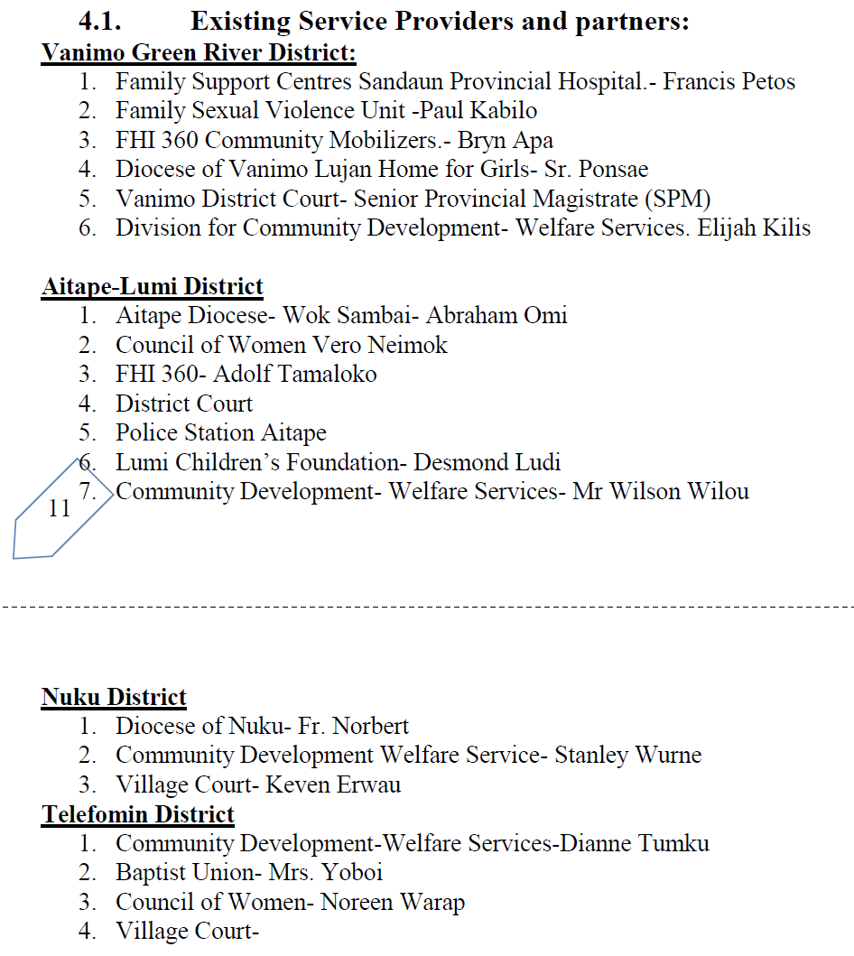

Vision and Mission
Some proposed text is provided below, which is adapted from the Vision and Mission of the National GBV Strategy. Please amend this text as appropriate for your province. You may also want to draw on relevant text from your existing Provincial Strategic Plan.
Some provinces have also included values statements or a bulleted list of values which are intended to provide guidance to all people across the province
PROPOSED TEMPLATE WORDING
OUR VISION: A province free from all forms of violence where people respect and support one another.
OUR MISSION To establish, maintain and strengthen effective, engaged and active partnerships within our provinces to respond to and prevent Gender Based Violence in our communities. By communicating effectively at all levels, we will ensure improved services to GBV survivors, increased public awareness, shared ownership in line with the National GBV strategy.

Outcomes and Outputs
Some proposed text for the strategy’s outcomes is provided below, which is adapted from the National GBV Strategy. Please amend this text as appropriate for your province.
Outcome 1: Provincial GBV Secretariat operational and working effectively to coordinate and support the work of all partners in addressing GBV.

Outcome 2: Intergrated GBV data collection coordinated across all stakeholders to support evidence based GBV policies, programming and monitoring of GBV work.

Outcome 3: GBV survivors accessing quality crisis response services, including in relation to counselling, safe houses, health services, policing and justice from the courts.

Outcome 4: GBV prevention activities effectively rolled out across the province, including through formulation of targeted messages and implementing coordinate awareness and education programmes.

Under each Outcome, you will need to identify your own outputs, which should represent they key pieces of work you will be implementing to achieve the Outcome. Developing the outputs that will combine to achieve the outcomes does not need to be a complicated process. In Morobe, they produced a list of bulleted outputs per outcome (see Annex 1 for their full summary of outputs). Each year, they then produced a budgeted activity plan, that listed the activities that would be implemented to progress each output.
EXAMPLE: Morobe GBV Strategy (2015-17)
Outcome 2 - Greater prevention activities and community awareness for FSV
Strategies developed in support of this outcome are as follows:-
2.1. Work with education to include FBV prevention in schools
2.2. Develop and distribute FSV Publicity materials (standardized) in Lae
2.3. Use local media to send FSV prevention/ awareness messages
2.4. Promote male advocacy and church/community based FSV programs in Morobe
2.5. Increase media awareness
2.6. Conduct 3 rural area outreach patrols annually
2.7. Provide Rural Health Centre Awareness to communities,

Developing the list of activities per output is a bigger process, which requires some detail. As such, most strategies included them in an annexed Activity Plan. You may want to develop:
- A multi-year workplan, which sets out the activities anticipated to be implemented in each year of the strategy (see Annex 2 for an example from Jiwaka) OR
- An annual workplan which is produced each year and submitted as part of the annual budget process (see Annex 3 for an example).

Coordination, implementation and monitoring structures
It is important that the provincial GBV strategy is anchored to a meaningful implementation structure. In 2013, the national Family and Sexual Violence Action Committees (FSVAC) secured a National Executive Council (NEC) directive to all provinces to provide adequate budgets and human and technical resources for Provincial GBV coordinating Committees to coordinate the collaboration and cooperation of government, NGOs and faith-based organisations to provide effective prevention and responses to violence against women and girls in their province. To date, this directive has only been operationalised in a handful of provinces.
The National GBV Strategy envisaged that each province would establish some form of provincial GBV secretariats (PBGVS), whose job it would be to coordinate GBV activities across the province. The PGBVS was NOT intended to implement all GBV activities. Rather, PGBVSs were to operate as government-funded GBV focal points who could operate within provincial government structures to advocate and raise funding to support the work of other GBV stakeholders.
Across the country, provinces have a range of different GBV coordination and implementation structures. Some provinces have set up PGBVS or have appointed/nominated a GBV focal point. Where this coordination structure exists, it should be referenced in the strategy. Ideally, a simple organigram should be included which explains how the PGBVS/focal point connects back to other provincial and national government bodies. Experience has shown that when PGBVS staff are being recruited, their position description should require that they have specific gender equality and/or GBV expertise, to ensure they can most effectively perform their role. This could also be mentioned in the strategy.
EXAMPLE: West New Britain draft GBV Strategy (2021-25)
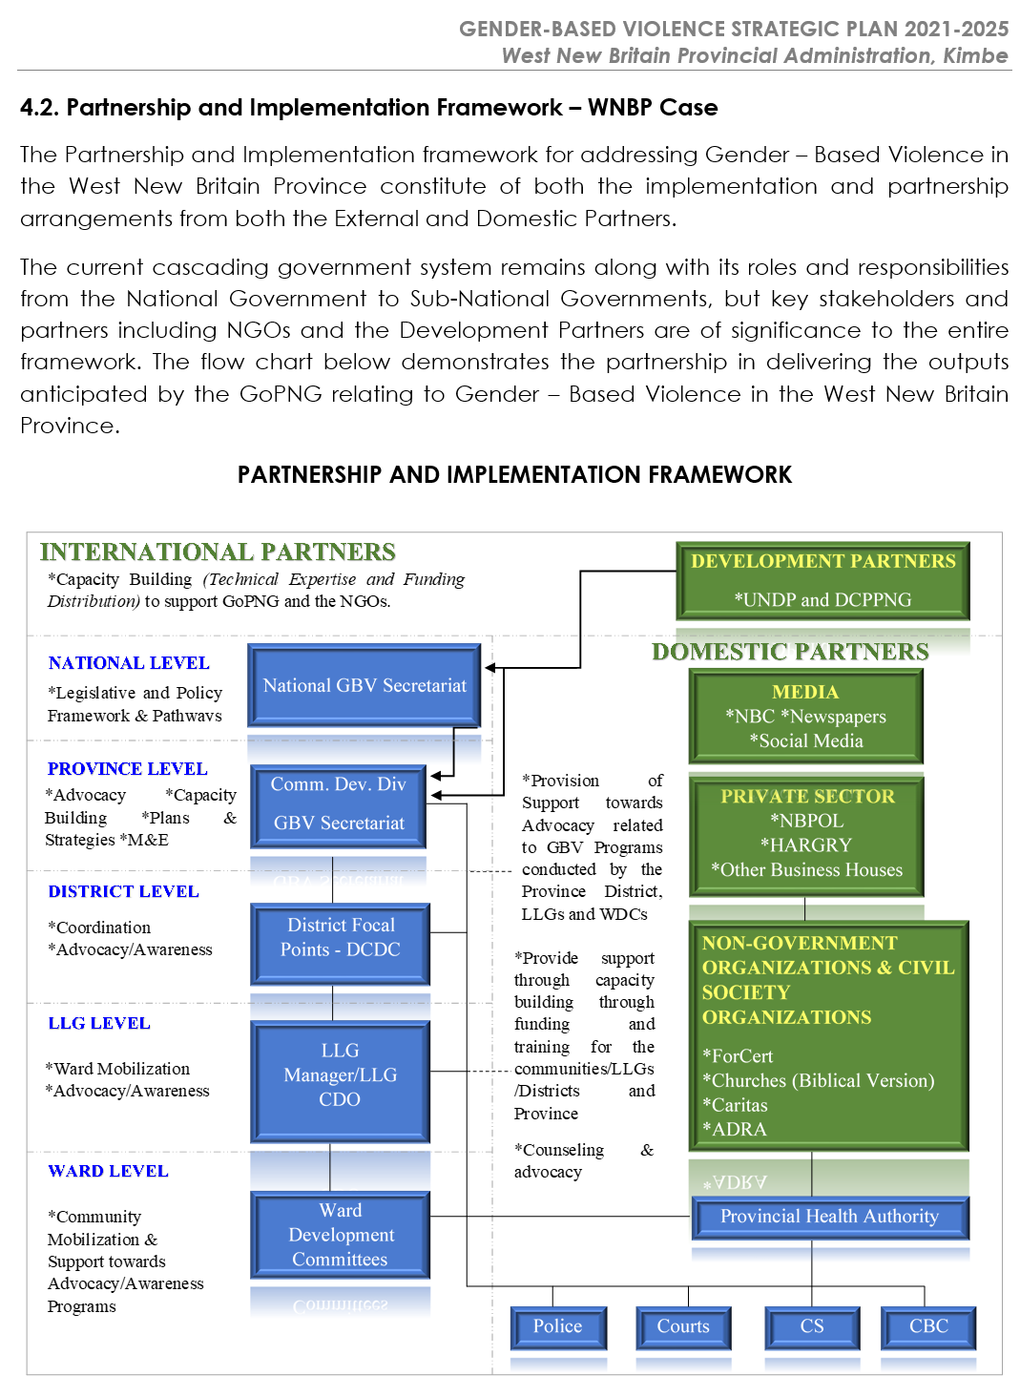
Some provinces have also established provincial-level FSVACs, which bring together GBV government and non-government stakeholders across the province to coordinate their activities and support GBV case management and referral pathways. FSVACs filled a critical gap in the absence of a government-funded provincial GBV focal point. Provincial FSVACs are usually supported through funding from the National FSVAC, which receives some funding from the CIMC as well as funding from donors.
Where a provincial FSVAC is in place, it is important for the strategy to clarify how the Provincial GBV Secretariat and Provincial FSVAC will work together. You may wish to annex the Terms of Reference for your Provincial GBV Secretariat and your Provincial FSVAC to the strategy.
EXAMPLE: Jiwaka GBV Strategy (2017-26)
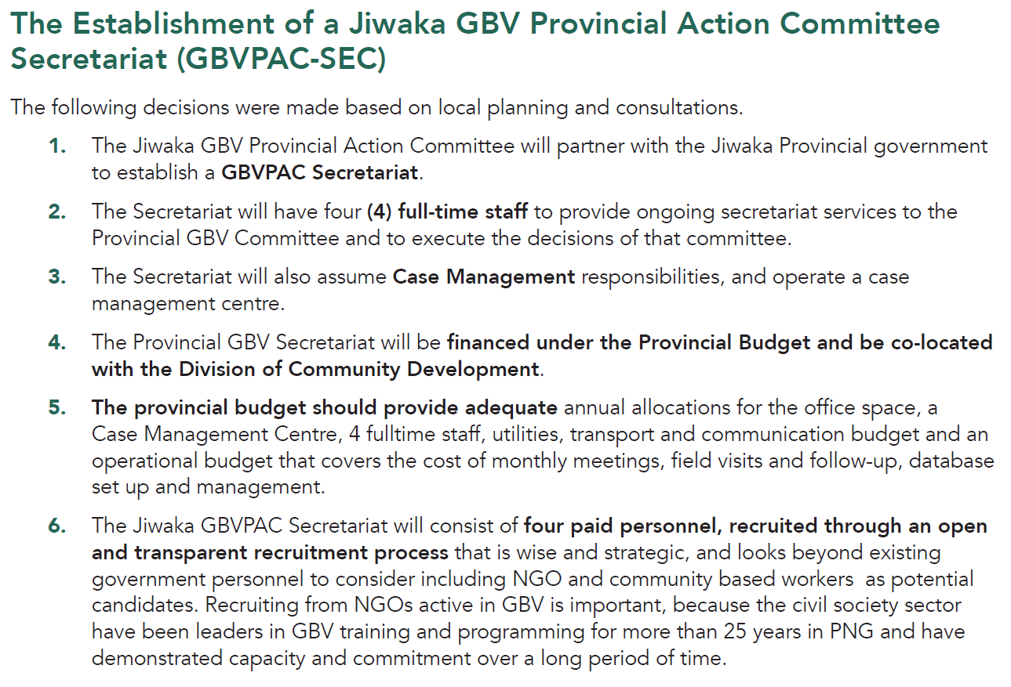
Some provinces have adopted a “whole-of-government” approach to their strategy, which recognised that addressing GBV is not the role only of the provincial GBV secretariat or FSVAC, but also depends on actions of other government bodies (most notably, health services, the police and the courts) and civil society service providers. These strategies have included these bodies in their implementation, referencing them explicitly as partners, and including them as “responsible parties” in their workplans and/or monitoring frameworks.

Monitoring framework / Performance indicators
Monitoring framework
The strategy should include a simple monitoring framework, which can be used to track your progress implementing the strategy over time. Existing provincial GBV strategies have taken different approaches to developing their monitoring framework.
Some provinces have included the performance indicators in the main text as a table (see boxed example below), some have included it as part of their annexed workplan (see Annexes 1, 2, 4 and 5 for examples). There is no one way that is right; it is simply important to develop clear, time-bound indicators that will help you to assess whether you are making real progress.
EXAMPLE: Sandaun Provincial GBV Strategic Plan (2016-19)
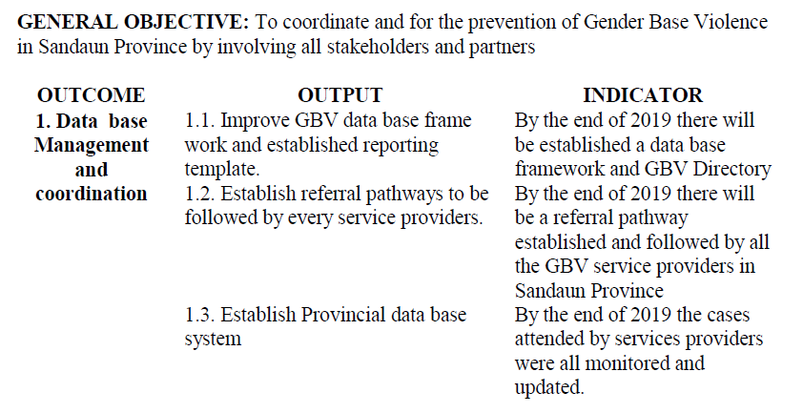
Reporting framework
Ideally, an annual report should be produced – by the Provincial GBV Secretariat or focal point – providing an update on implementation of the strategy. This should be noted in the strategy, which should make clear who should produce the report and by when, i.e by 31 January of the following year.
The reporting framework should also specify to whom the annual report should be submitted. Ideally, the annual report should be shared with the National GBV Secretariat, to enable them to monitor GBV activities across the country. It should also be provided to the Governor, the Provincial Assembly and the Provincial Administration.

Annex 1: Morobe GBV Strategy outcomes & outputs (monitoring framework)
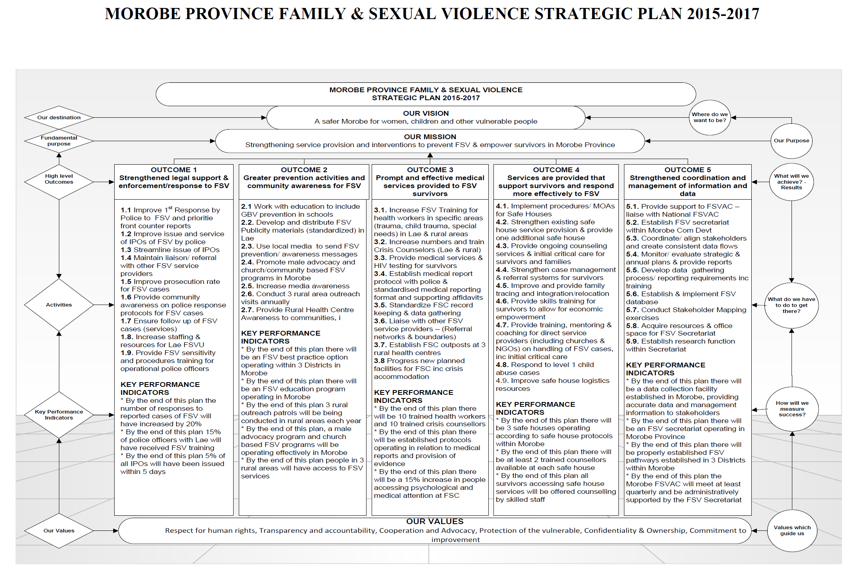

Annex 2: Jiwaka GBV Strategy – multi-year workplan, budget and indicators
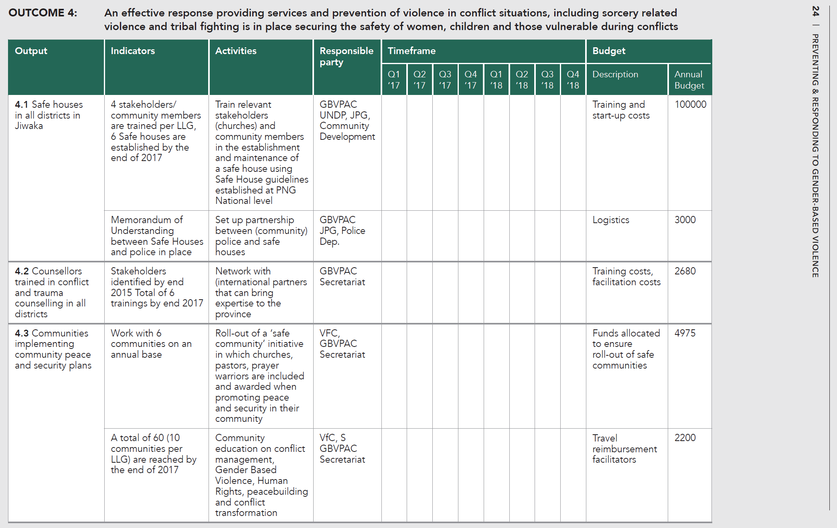

Annex 3: Sandaun GBV Strategy – annual activity plan and budget
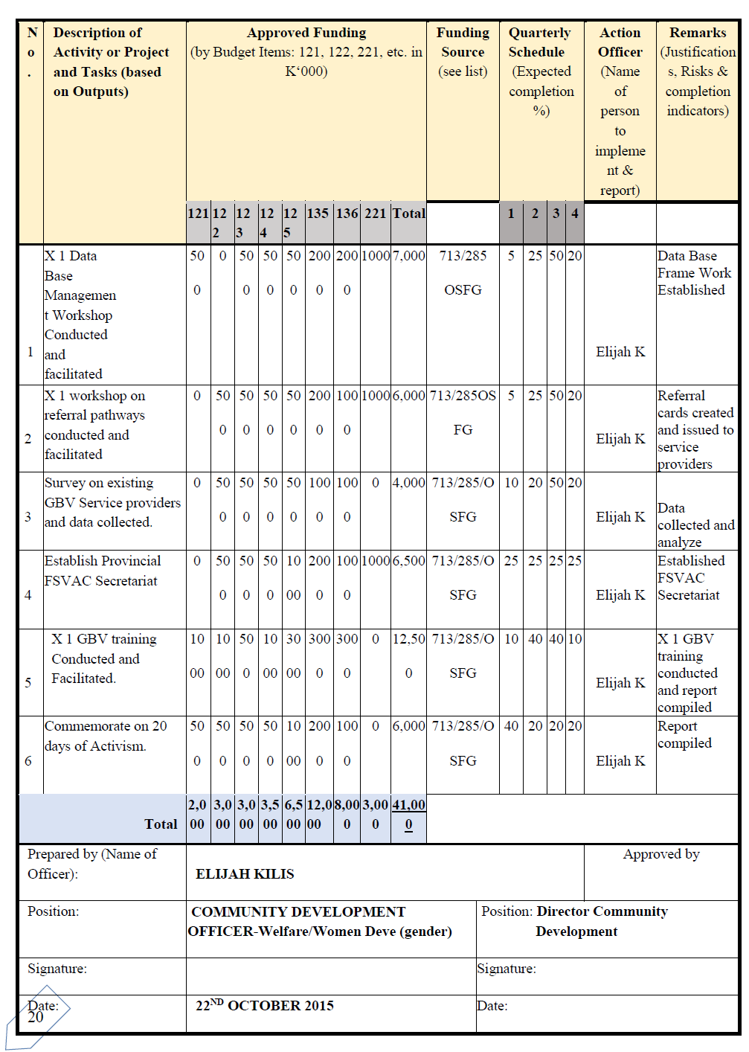
Annex 4: NCD GBV Strategy 2020-22 outcomes & outputs (monitoring framework) *
* The final column “objectives” should read “indicator”
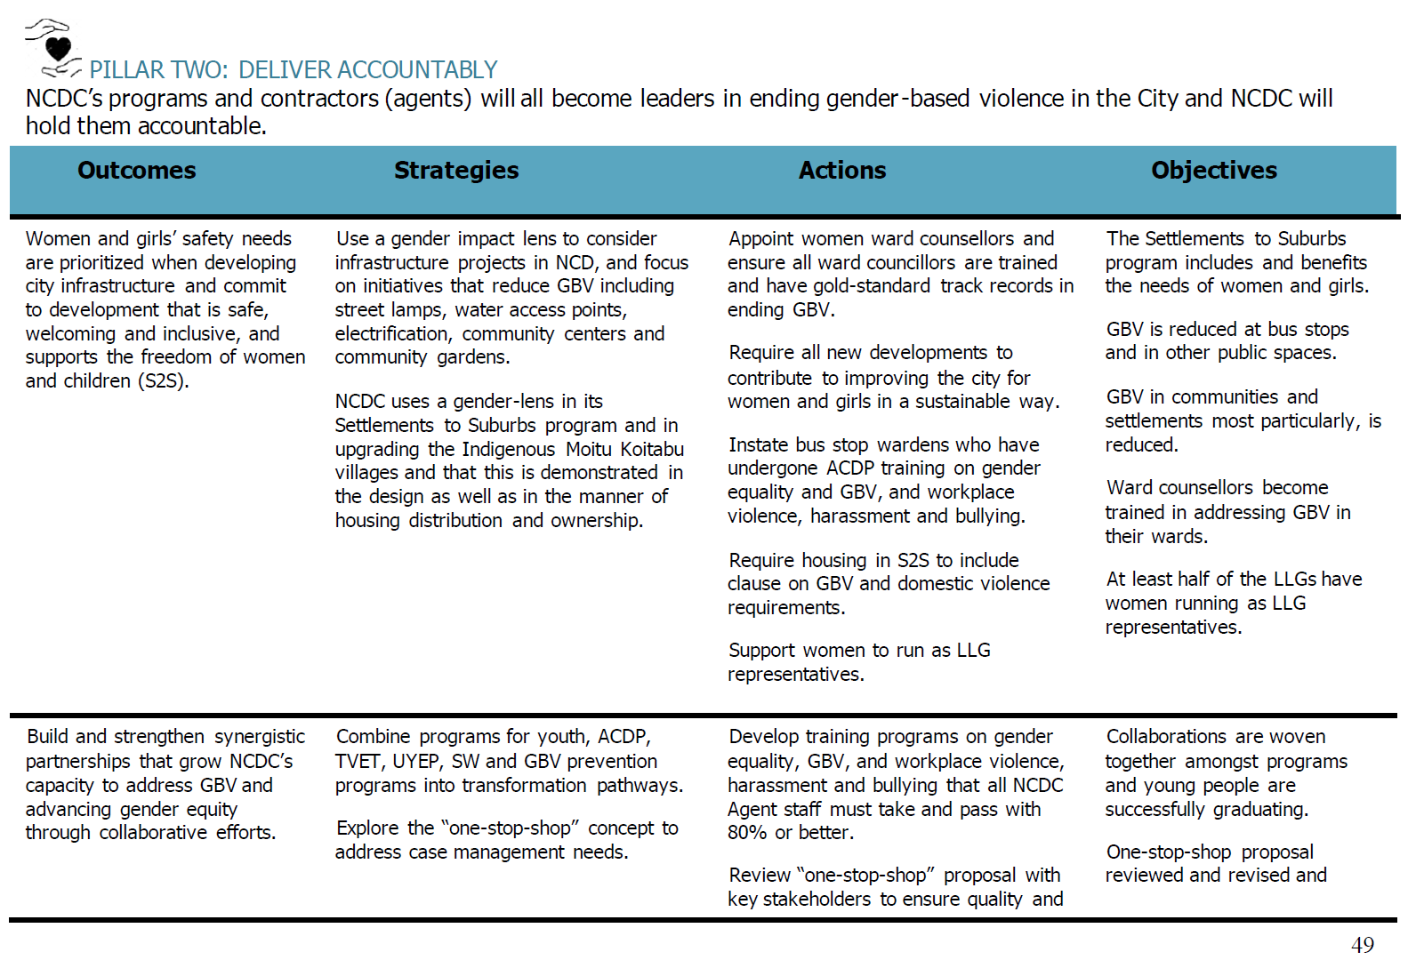
Annex 5: NCDC GBV Strategy (2016-18) – Workplan & Monitoring Framework
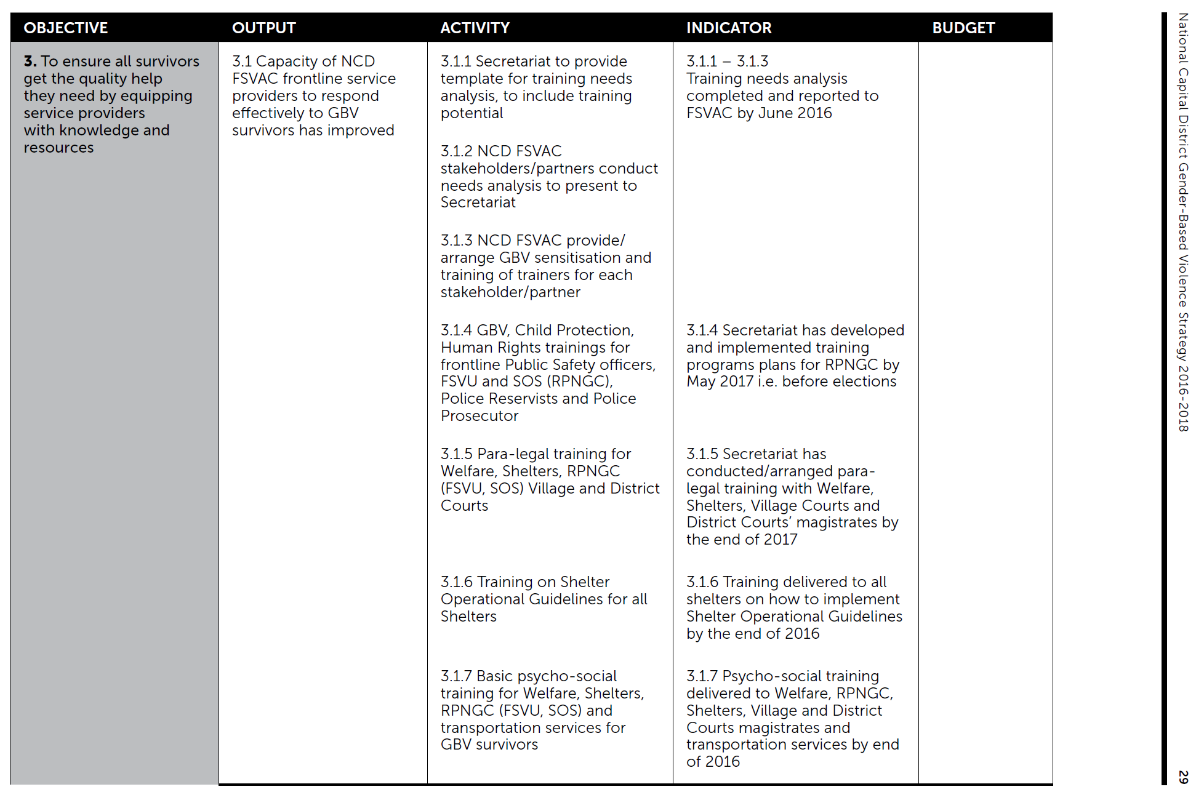

Some of these have now been renamed as GBV Action Committees (GBVAC).

